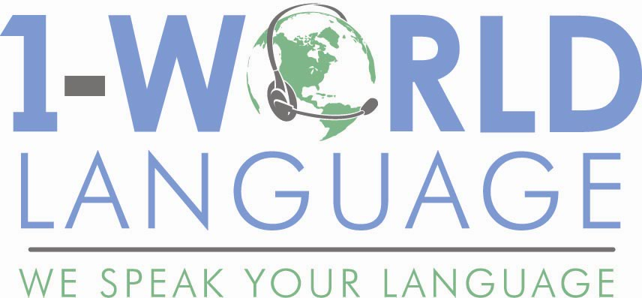
TELEPHONIC INTERPRETING
Implementation Materials

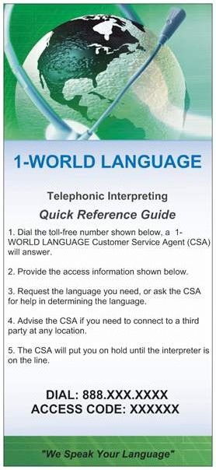
QUICK REFERENCE CARD (4" x 6")
This handy card lists the service access information for quick reference.

___________________________________________________________________________________

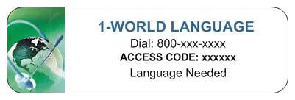
LABELS (2.5" x 1")
Place these labels on phones, ID badges, or patient folders for quick reference of your service access information.

___________________________________________________________________________________

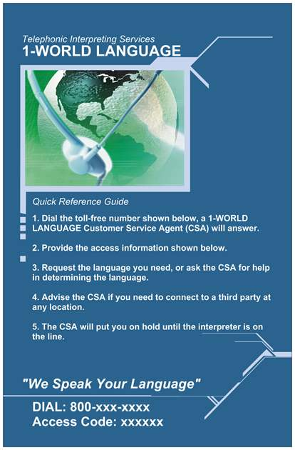
QUICK REFERENCE & LANGUAGE ID POSTER
Various sized materials that state how to access the telephone interpreters, and some that state “Point to your language and an interpreter will be provided to you at no cost” in the most frequently requested languages and dialects nationwide.
• Mini Poster (9" x 12") – Top 24 languages & Dialects
• Easel (9" x 12") – Top 24 Languages & Dialects
• Large Poster (18" x 24") – Top 24 Languages & Dialects
• ID Brochure – Top 55 Languages & Dialects

__________________________________________________________________________________

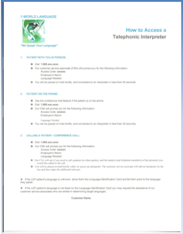
HOW TO SHEET (8.5" x 11")
Provides step-by-step instructions on how to use our telephone interpreting service in three different scenarios.

PH 504.388.0411 FAX 888.294.8815 WEB 1worldlanguage.com

